**Internet Traffic Measurement Project Report**

Satish Erappa, Manoj Prakash

1. **Probabilistic Counting**

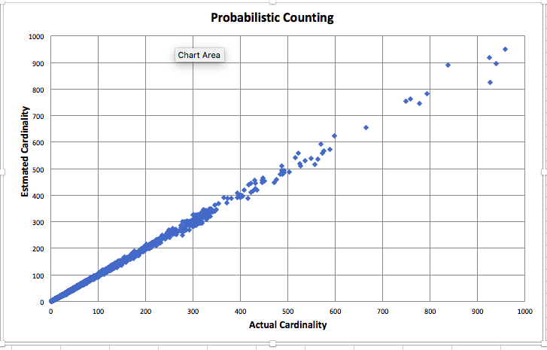

Figure : Magnified graph to show cardinality up to 1000, 512 bits per flow

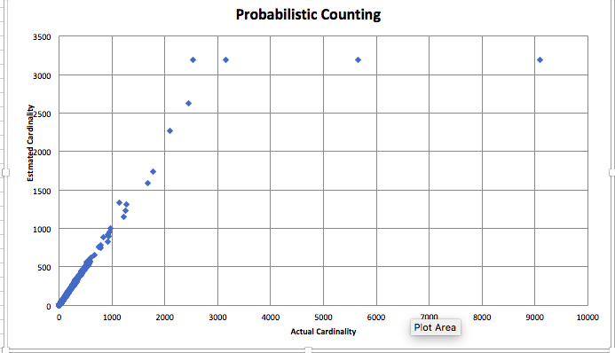

Figure : Full graph, 512 bits per flow

**2.Virtual Bitmap**

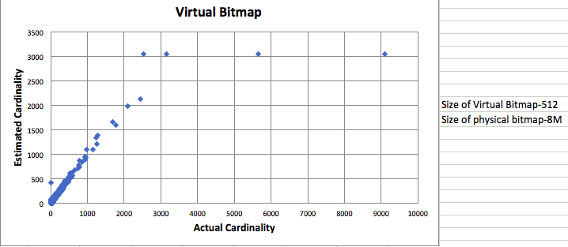

Figure : All flows

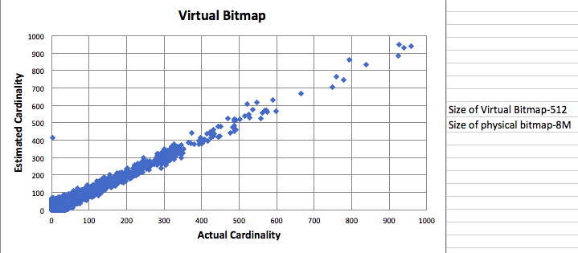

Figure : Magnified graph to show only max cardinality of 1000

**3. PCSA**

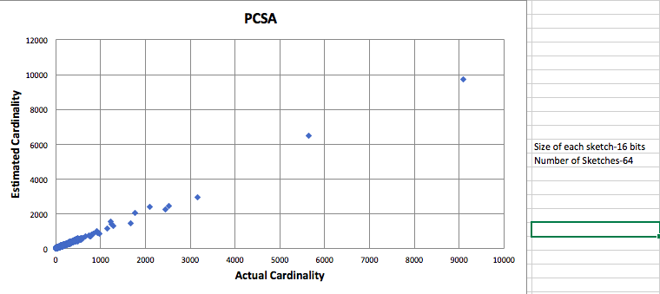

Figure :All flows

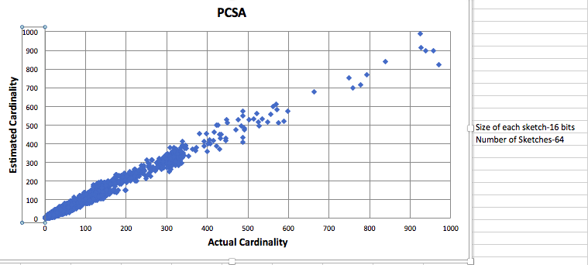

Figure : Magnified graph to show only max cardinality of 1000

4. Hyper Log Log

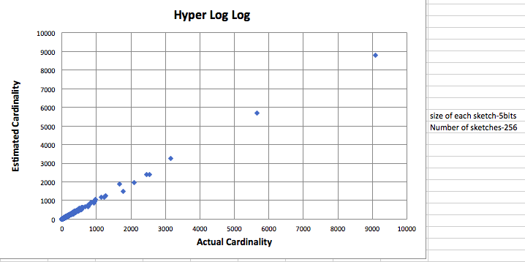

Figure : All Flows

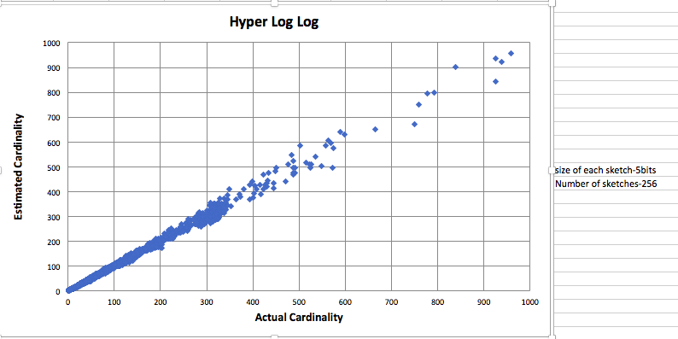

Figure : Magnified graph to show only max cardinality of 1000

5. Virtual Hyper Log Log

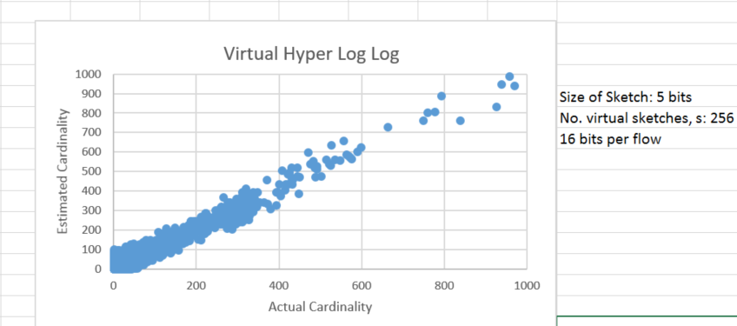

Figure : Magnified graph to show only max cardinality of 1000

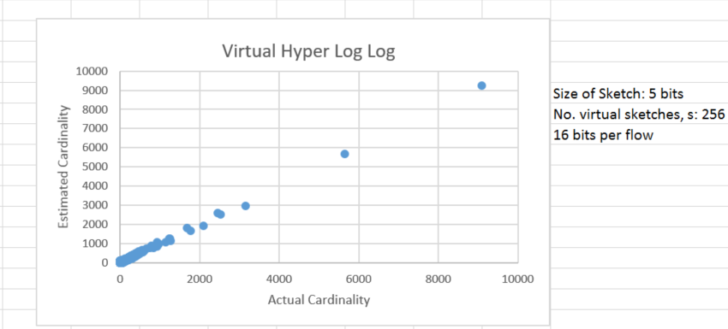

Figure : All flows